***Time to Sleep……***



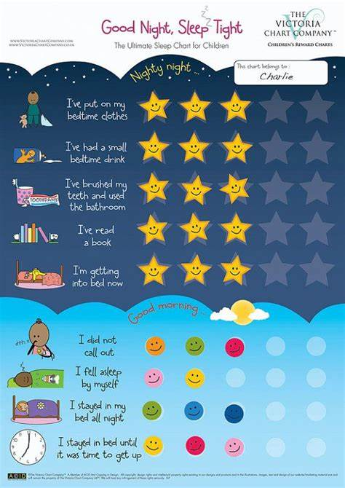

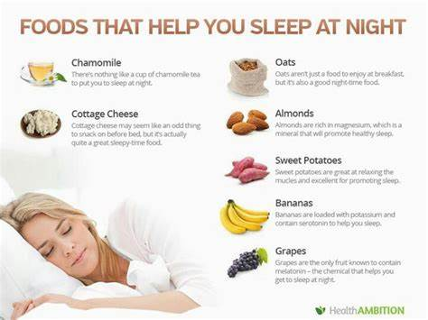

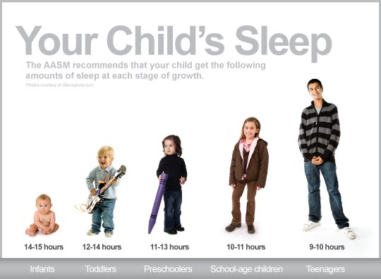



“Don’t shut the door!”

“It’s so dark in here!”

“Please don’t leave!”

**“I just can’t sleep.”**

Do you hear any of these phrases at night when you’re putting your child to bed?

When your child won’t go to sleep, it can be both exhausting and frustrating because it affects everyone in the family. When one kids is awake, sometimes that means EVERYONE is awake.

In those moments of frustration, you might catch yourself thinking — Why are they so scared of *nothing*? Why won’t they *just go to sleep?!* It’s OK, we’ve all been there.

**Here’s the thing: your child *wants* to sleep.**They really do!

It might seem like your kids have inexhaustible energy, but I promise they don’t really have super-powers. **Your child *needs* sleep. But sometimes they just *can’t*.**

Interestingly, sleep issues and fear of the dark might not actually be about sleep or the dark itself – rather, **problems sleeping can be** [**symptoms of anxiety**](http://www.todaysparent.com/toddler/sleep-solutions-for-all-ages/) **and stress.**

6 Ways to Ease Sleep Anxiety in Children

Just like in adults, sleep anxiety in children can be caused by feelings of powerless or lack of control in certain situations. However, they might not want or know how to tell you that they’re feeling worried or anxious.

Instead, they’ll say things like, “I can’t sleep” or even “[my stomach hurts](https://loveandmarriageblog.com/kids-say-my-stomach-hurts/).”

The game-changer with our own daughter was finding things that make her feel *empowered*.

While they might not specifically fix an outside situation that is causing her anxiety (which might also be out of *my* control as well), the following tricks help **give her a feeling of control over herself and her environment.**

This, in turn, greatly alleviates the stress that is keeping her awake at night.

1. Make Your Child’s Bedroom a Safe Place

Of course your house is probably the safest place your child can be, and you know that. But I’m not referring to safety in such a physical/literal sense.

Instead, consider whether your child’s room is a haven for them from the outside world (even from the rest of the house).

Is it a place where they can have quiet time if they become over-stimulated? Is it a place where they have some degree of control over their surroundings?

The first thing we did is to make sure that my daughter’s room is a safe place in *her* mind.

It is not a place for punishment, but rather it is a place where she can recharge, have [time to herself](https://thesoccermomblog.com/2016/05/19/alternative-to-time-out/), and set her own boundaries for being around other people. It is decorated in her favorite colors and she displays her most special possessions as she sees fit.

This way, my daughter views “going to her room,” even for bedtime, to be a positive thing.

2. Create a Calm Environment

Reducing the chaos in your child’s room can help reduce their overall stress. My daughter likes things to be very orderly and in their “place.” When her room is messy, I have noticed that she is uneasy, so every evening [we tidy up](https://thesoccermomblog.com/2015/09/22/how-your-kids-can-help-organize-their-own-room/) and put things where they belong. This ability to control her environment is so important in creating a sense of empowerment that will counteract anxiety.

Another contributor to “chaos” is the presence of electronics. There are no televisions, computers, etc. in our children’s rooms because these are all distractions to sleep.

3. Stick to a Consistent Bedtime Routine

Children thrive on routines because while so many things in life are unexpected, routines are predictable and safe. A significant bedtime routine (ours takes about 30-45 minutes) also signals your child that you are in the wind-down stage and gives them adequate time to do so.

We do our bedtime tasks in the same order every single night: bath, pajamas, brush teeth, bedtime story. The girls love knowing and calling out the next step. We finish with a bedtime story which is of course the favorite part.

Our girls actually *love* getting ready for bed because we have made the routine fun and it is something in which they are active participants.

4. Take Time to Listen to Your Child

When your child is anxious, it could be an ongoing issue that you’re aware of; however, it could also be caused by a specific incident. Maybe there was an encounter with a [bully at school](https://thesoccermomblog.com/2016/03/06/signs-of-bullying/) earlier that day. If you want to know what is worrying your child, don’t assume – ask.

Knowing that you care and that they have been heard will comfort to your child. It also allows you to reassure them and discuss possible solutions to problems that might be affecting more than just their sleep (and problems you may not have been aware of yet).

After you’ve finished your bedtime routine, sit down with your child and invite them to talk to you about whatever is on their mind, good or bad.

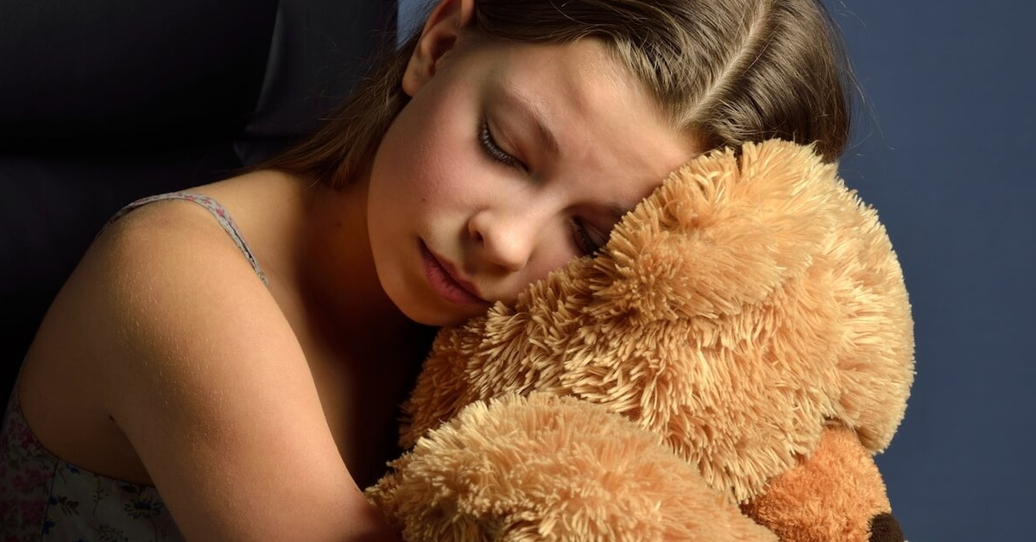

*For your convenience, we’ve included shop-able links to the products/services we love; disclosure policy*[here.](https://thesoccermomblog.com/disclosure)

5. Look for Sleep Aids to Help Your Child Sleep Better

When I say “sleep aid,” I don’t mean medicine or anything like that, but rather tools that can help your kid fall asleep or feel more comfortable.

Comfort items are something your child can look to for extra reassurance, again giving them something *they can do* to soothe fears and negative emotions.

**These are a few of the sleep aids that have been very helpful for both my daughters:**

* Night light (my daughter loves this [projectable night light](https://www.amazon.com/gp/product/B00HCMPR2K/ref=as_li_qf_sp_asin_il_tl?ie=UTF8&tag=thsomobl-20&camp=1789&creative=9325&linkCode=as2&creativeASIN=B00HCMPR2K&linkId=e351eae14d5e9c5c568113e636a0c164) because she can see her favorite characters)
* Special stuffed animal or blanket to snuggle as they fall asleep
* Guided meditation recordings or soft music
* [Lavender essential oil](https://www.mydoterra.com/staceygarska/#/joinAndSave) (We purchase all of our essential oils through DoTERRA; [click here to read more about why I chose DoTERRA plus 12 of my favorite everyday uses for essential oils](https://thesoccermomblog.com/2017/07/30/everyday-essential-oil-uses/))
* [Aromatherapy essential oil diffuser](https://www.amazon.com/gp/product/B014SF6MBI/ref=as_li_qf_sp_asin_il_tl?ie=UTF8&tag=thsomobl-20&camp=1789&creative=9325&linkCode=as2&creativeASIN=B014SF6MBI&linkId=2033922eeedc75e2b95265999620395d) (Our girls *love* this cute little diffuser with changing color LED nightlight; it’s also a humidifier which can help with breathing and allergies)
* Books about anxiety — [**this reading list**](https://happilyeverelephants.com/home/books-for-kids-with-anxiety) from kids book expert Lauren at Happily Ever Elephants is full of great options to help kids deal with anxiety and get past their worries.
* [**Weighted blanket**](https://www.amazon.com/gp/product/B07G2RBFSJ/ref=as_li_qf_asin_il_tl?ie=UTF8&tag=thsomobl-20&creative=9325&linkCode=as2&creativeASIN=B07G2RBFSJ&linkId=1c083c6a9e74cdce3dfd48540b33546c) — Our youngest daughter especially loves the feel of a weighted blanket. It helps her fall asleep faster and stay asleep longer!

6. Empower Your Child So They Can Self-Soothe

Self-soothing is usually mentioned when you’re talking about [baby sleep regressions](https://thesoccermomblog.com/baby-sleep-regression/) or even toddlers, but it helps older kids sleep better too.

**Fear and anxiety are rooted in feelings of powerlessness**, so one of the best things you can do is to empower your child. Give your child a way to feel like they are in control of their emotions.

For your family, this might mean saying a prayer asking for a restful night’s sleep and relief from worry. Or you might prefer to guide your child in saying positive affirmations, along the lines of:

***“I did my best today. I give myself permission to relax. I feel peaceful. I will now slip into restful sleep.”***

Encouraging your child to take deep breaths as they fall asleep can also help the process. These are all tools that your child can use throughout the rest of their life to self-soothe.

When Dealing with Child Sleep Anxiety Remember This

Your child *wants* to sleep. I said it earlier in the post, but I want to repeat it because it is so important! Kids need sleep, they want sleep. Sometimes they just need extra help to make it happen.

The above tips might not all work for every kid, as every child and every situation is different. However, I hope that these will provide a starting point and help your family like they did ours.

✕Top of Form

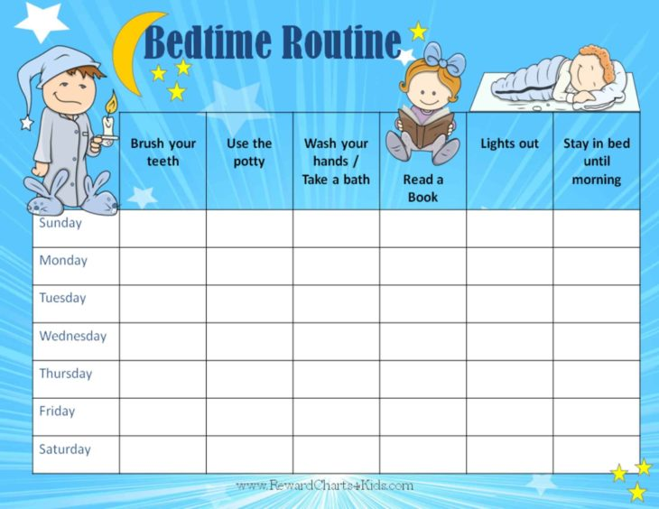

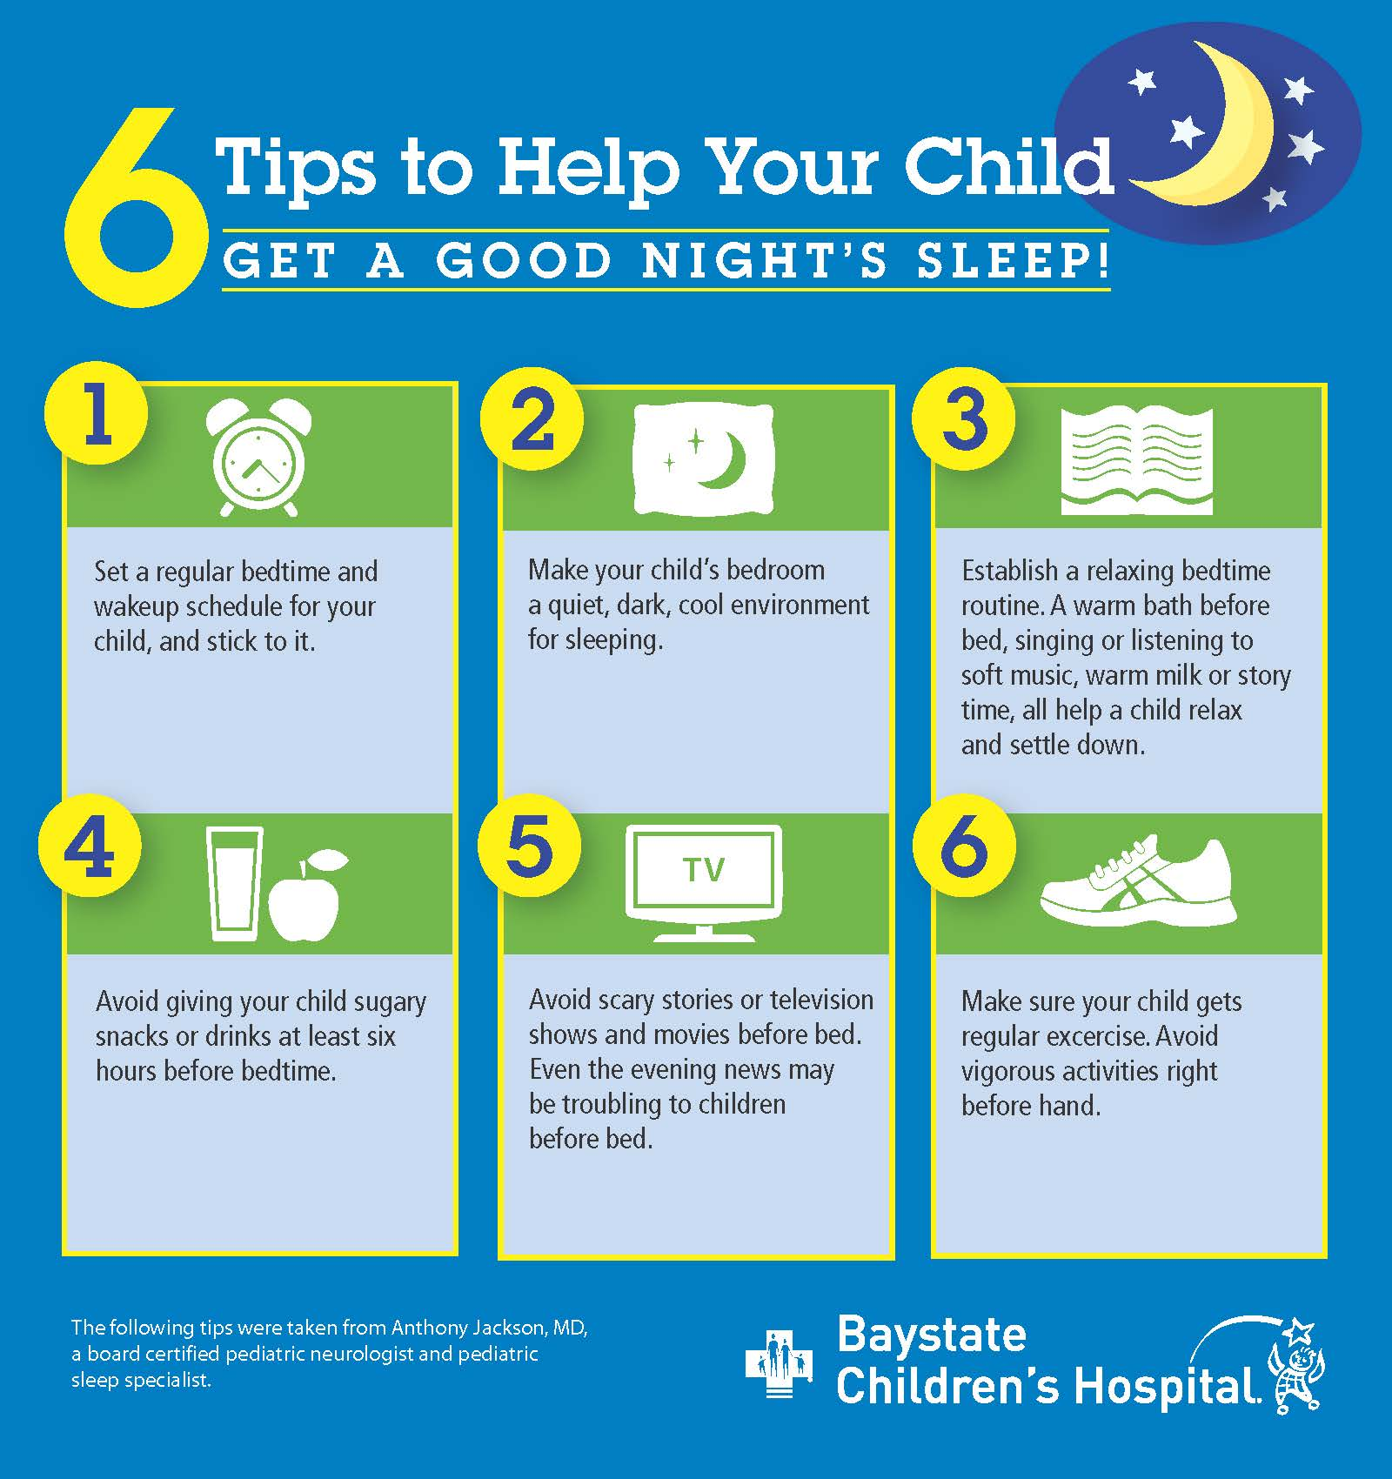



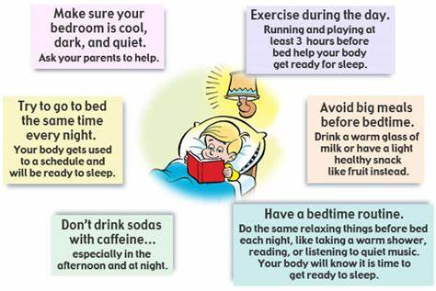

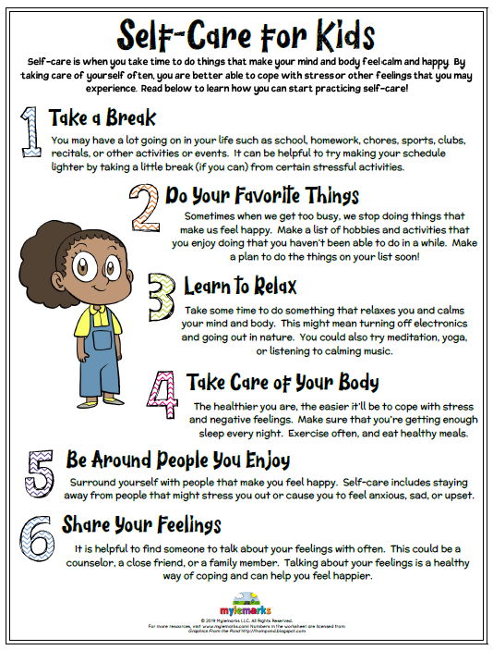

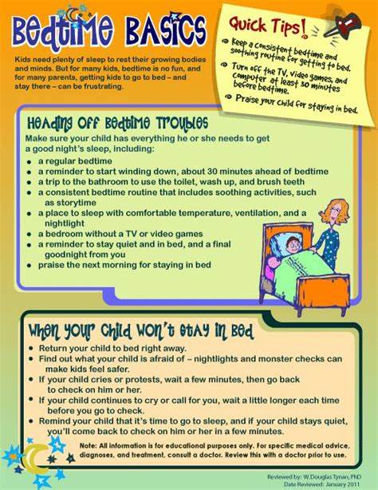

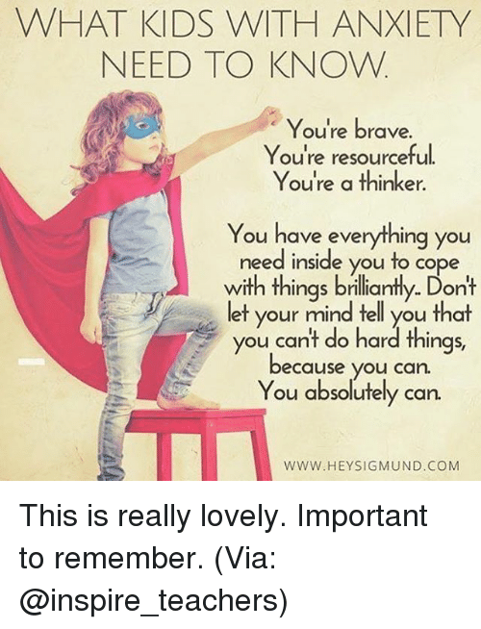

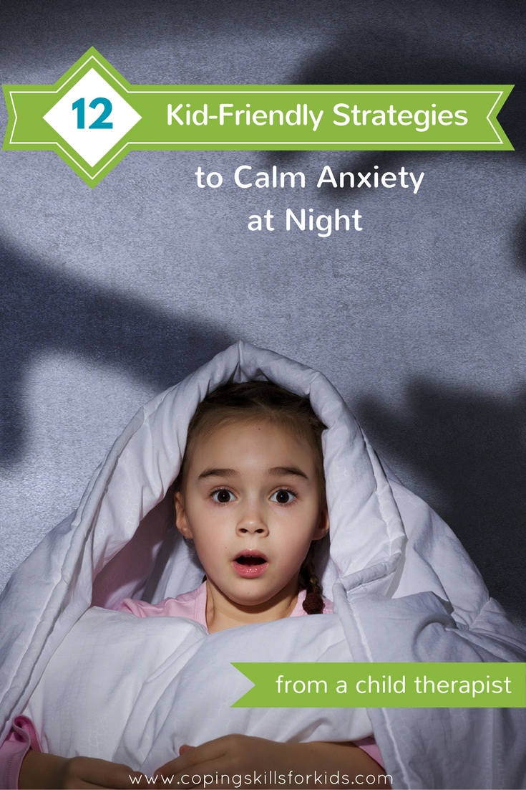

September 9, 2016

[Calming Coping Skills](https://copingskillsforkids.com/blog?category=Calming+Coping+Skills), [Coping Skills](https://copingskillsforkids.com/blog?category=Coping+Skills), [Anxiety in Children](https://copingskillsforkids.com/blog?category=Anxiety+in+Children)

[Janine Halloran](https://copingskillsforkids.com/blog?author=528e56d6e4b0cf0adc8ecd10)

**12 Kid Friendly Strategies to Calm Anxiety at Night from a Child Therapist**

[Janine Halloran](https://copingskillsforkids.com/blog?author=528e56d6e4b0cf0adc8ecd10)

[September 9, 2016](https://copingskillsforkids.com/blog/12-kid-friendly-strategies-to-calm-anxiety-at-night-from-a-child-therapist)

[Calming Coping Skills](https://copingskillsforkids.com/blog/category/Calming+Coping+Skills), [Coping Skills](https://copingskillsforkids.com/blog/category/Coping+Skills), [Anxiety in Children](https://copingskillsforkids.com/blog/category/Anxiety+in+Children)

[12 Kid Friendly Strategies to Calm Anxiety at Night from a Child Therapist](https://copingskillsforkids.com/blog/12-kid-friendly-strategies-to-calm-anxiety-at-night-from-a-child-therapist)

[Janine Halloran](https://copingskillsforkids.com/blog?author=528e56d6e4b0cf0adc8ecd10)

[September 9, 2016](https://copingskillsforkids.com/blog/12-kid-friendly-strategies-to-calm-anxiety-at-night-from-a-child-therapist)

[Calming Coping Skills](https://copingskillsforkids.com/blog/category/Calming+Coping+Skills), [Coping Skills](https://copingskillsforkids.com/blog/category/Coping+Skills), [Anxiety in Children](https://copingskillsforkids.com/blog/category/Anxiety+in+Children)

***Inside: 12 proven strategies to help your child's anxiety and help them settle in for a long night’s sleep***

You're finally settling onto your couch, remote in hand and ready to start binge watching your latest Netflix obsession. You're just about to press play when you hear tiny feet padding down the hall.

“Mommy? I can't sleep. I'm scared!!”

How many times has this happened? Your child has struggled with their nighttime fears for what feels like forever and you've tried all the tricks you know - setting up a regular routine,, reassuring him nothing will happen, night lights, warm milk, laying down with him, etc. Nothing is working. What can you do? Here are a few ideas that have worked for my clients and my own children.

**Pinpoint what the fear is**

One of the most important things to do is to figure out exactly what is causing the anxiety. Is it fear of the dark? Is it a worry about something in the closet? Is it monsters? Is it spiders? Figuring out the cause of the fear will help you come up with ways you can help your child combat it.

**Rearrange the room**

Are there particular spots of the room that seem to be darker or cause more fear at night than others? Go into the bedroom during the day with your child and talk about the spots that make your child nervous. Try moving night lights and furniture around for a more calming room arrangement.

**Calming Scripts**

There are scripts written specifically to help calm children and relax them at night. You can read them [a script like this one](http://www.innerhealthstudio.com/afraid-of-the-dark.html) from Inner Health Studio that is focused on helping them not be afraid of the dark. Or you could have them listen to a pre-recorded script. Here's one I love called [Sleep Tight](http://www.shambhala.com/images/illus/Sitting_Still_audio/12.%20Exercise%2011%20-%20Sleep%20Tight.mp3) from the Book Sitting Still Like A Frog by Eline Snel.

**Transitional Objects**

If your child has a hard time separating from you, try a transitional object. This is a special item that helps your child feel comforted. It helps them feel like part of you is still present even when you're not there. It could be something like a stuffed animal or a special stone or necklace, or a sweatshirt of yours. The object isn’t what matters, it’s what the object represents. They can keep it and hold it all night long to help them relax and go to sleep.

**Read a book to help calm anxiety at night**

There are several children’s books that have characters who are afraid of the dark. Sometimes it helps kids to know they're not the only ones who get scared. Try reading one of these to help your child realize they’re not the only one who gets scared at night.

[](http://www.amazon.com/Berenstain-Bears-Dark-First-Books/dp/0394854438?SubscriptionId=0ENGV10E9K9QDNSJ5C82&tag=encoplay07-20&linkCode=xm2&camp=2025&creative=165953&creativeASIN=0394854438)

[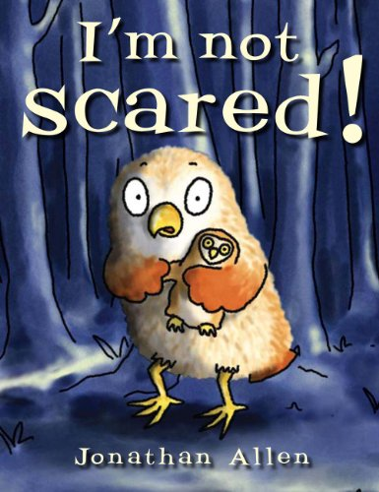](http://www.amazon.com/Im-Not-Scared-Baby-Owl/dp/1907152636?SubscriptionId=0ENGV10E9K9QDNSJ5C82&tag=encoplay07-20&linkCode=xm2&camp=2025&creative=165953&creativeASIN=1907152636)[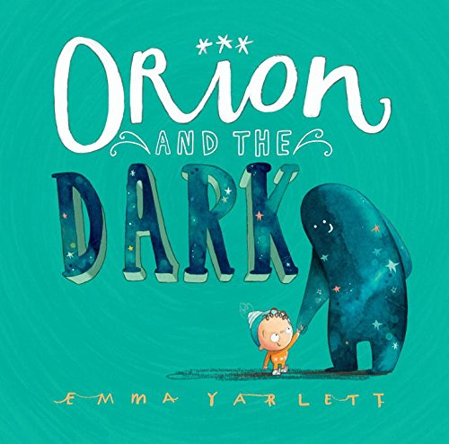](http://www.amazon.com/Orion-Dark-Emma-Yarlett/dp/0763675954?SubscriptionId=0ENGV10E9K9QDNSJ5C82&tag=encoplay07-20&linkCode=xm2&camp=2025&creative=165953&creativeASIN=0763675954)

**Yoga**

Certain yoga poses are helpful for calming a body down and getting ready for rest at night. One of my favorites is to have your child lay down on their back with their legs perpendicular up against a wall. Have them put their arms out to their sides. Encourage them to do some deep breathing as they lay like this. If it’s possible, have them do this pose in their bed, so it’s easier to transition them to laying in bed for sleep.

[Progressive Muscle Relaxation](https://www.youtube.com/watch?v=8Xp2UzG7UYY)

Progressive Muscle Relaxation, or PMR, is a systematic way of going through all your muscle groups to tense and relax the muscles, typically starting at the top of your body and going all the way down. Usually after tensing and relaxing muscles, your body feels more relaxed. Try doing a whole body progressive muscle relaxation designed especially for  for kids.

**Audiobooks**

One thing my kids love to do is listen to audiobooks in bed. There are so many great kids’ titles out there. The beauty of apps like of [Audible](http://amzn.to/2cLEgIc) is that they usually have a sleep timer. They can distract themselves from their anxiety by listening to a story while they relax in their bed.

**Try a different nightlight**

There are so many types of night lights you can try. When my kids were younger, they both loved the what they called their “Turtle” night light. It was the [Cloud b Twilight Constellation Night Light](http://amzn.to/2bZGOkE), and when it was lit up at night, it showed constellations on the ceiling and walls in their room.

Now my son is partial to the [Projectables LED Plug-In Night Light](http://amzn.to/2cJ3mDG) of Spider-Man. This displays a huge image of Spider-Man wherever the light is pointed. My son loves the idea that a superhero is in his room at night with him.

There are some other neat nightlights too, try a new one and see how your child responds.

[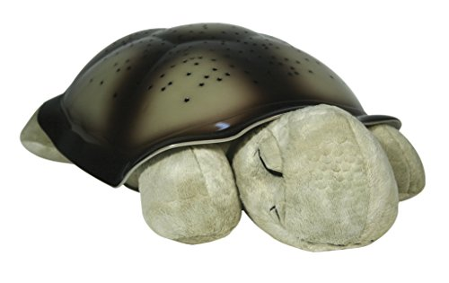](http://www.amazon.com/Cloud-Twilight-Constellation-Night-Turtle/dp/B000BNQC58?psc=1&SubscriptionId=0ENGV10E9K9QDNSJ5C82&tag=encoplay07-20&linkCode=xm2&camp=2025&creative=165953&creativeASIN=B000BNQC58)

[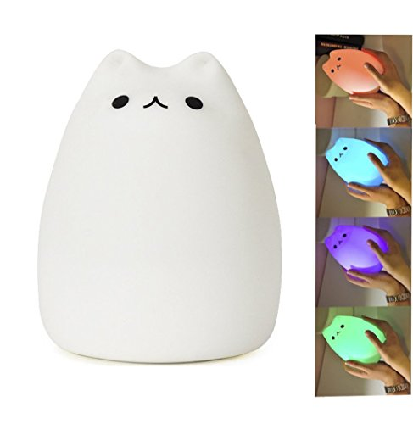](http://www.amazon.com/Mystery-Multicolor-Rechargeable-Breathing-Sensitive/dp/B01E8M302U?psc=1&SubscriptionId=0ENGV10E9K9QDNSJ5C82&tag=encoplay07-20&linkCode=xm2&camp=2025&creative=165953&creativeASIN=B01E8M302U)

**Calming Sounds Apps**

There are apps that have sounds you can have your child listen to as background noise, if they get scared of unusual noises at night. Some have nature sounds, some have soothing music. Others have sleep scripts as part of the app as well. Try out a few and see what works best for your child. Here are some free ones I like:

* [Relax melodies](http://www.ipnossoft.com/app/relax-melodies/)
* [Relaxing sounds](https://itunes.apple.com/us/app/relaxing-sounds-sleep-well/id502222888?mt=8)
* [Nature Sounds Relax and Sleep](https://play.google.com/store/apps/details?id=com.zodinplex.naturesound&hl=en)
* [Relaxing Sounds](https://play.google.com/store/apps/details?id=sleepandrelax.nature.sounds&hl=en)

**Podcasts**

Did you know there are podcasts with bedtime stories for children? Usually the hosts have a soothing voice and the stories tend to be pretty short. You can even listen to these podcasts during the day as a way to have some down time, too.

* [Tales from the Lilypad](http://www.talesfromthelilypad.com/)
* [Story Time](http://www.stitcher.com/podcast/bedtime-fm/story-time)
* [Stories Podcast](http://www.stitcher.com/podcast/stories-podcast)
* [Storynory](http://www.storynory.com/)

**Calming Jars**

Watching the glitter settle in a [calming jar](http://store.copingskillsforkids.com/products/diy-calming-jar) is a simple way to help kids settle their minds. Have them imagine their mind settling and calming as the glitter settles in the bottom of the jar. You can make it really simple with glitter paint and sequins or make it fancier with glow in the dark stars, Legos or other items.

Bottom of Form

✕