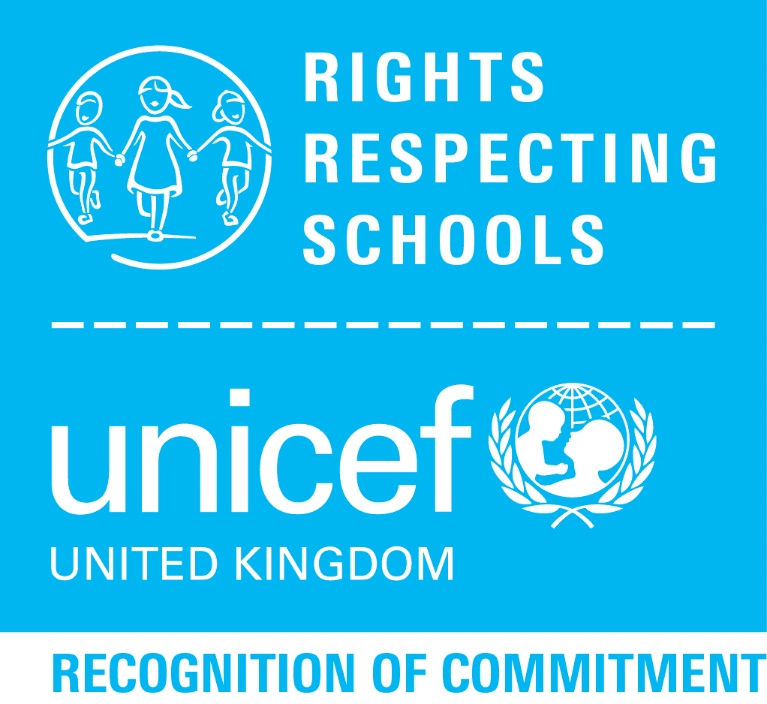

Right of the Month

March-Article 30 from the United Nations Convention on the Rights of the Child- “The right to enjoy your own culture, practise your own religion and use your own language’”